Undergraduate Project Report

Reconstruction of OFF alpha retinal neurons using SBEM images.

By

Anuran Samanta

BE22B006



Department of Biotechnology

Bhupat and Jyoti Mehta School of Biosciences IIT Madras

Research Supervisors:

Dr Santhosh Sethuramanujam

Mr. Narendra Pratap Singh

Ms Shubhranvita Mallik

Table of Contents

**Introduction**3

Neural reconstructions3

SBEM4

Alpha Cells5

Synapses5

**Methods6**

**Results7**

**Discussions10**

**Future Plans12**

**References12**

Introduction:

Neural reconstruction

Neuronal reconstruction is the process of creating detailed 3D maps of neurons from Serial Block-face Electron Microscope images. It involves tracing the paths of neurons to understand their structure and how they connect within the brain, retina, spinal cord or other tissues.  
Reconstruction of neurons from high resolution SBEM images enables us to accurately visualize and locate the soma, synapses, dendrites and axons of neurons in a given section of tissues. With the help of such reconstructions, we can identify certain features like synaptic distribution in healthy v/s transformed or diseased cells and arborization. It is also crucial in studying connectomics.

Connectomics is the study of maps of the neural connections within an organism's nervous system.   
It involves creating detailed maps of neural circuits at various scales, from individual synapses to large-scale brain networks. For example, the distribution of synapses in the neurons can be correlated with its function and selectivity of response towards a particular direction or neuronal connection, as we shall see later in the report.

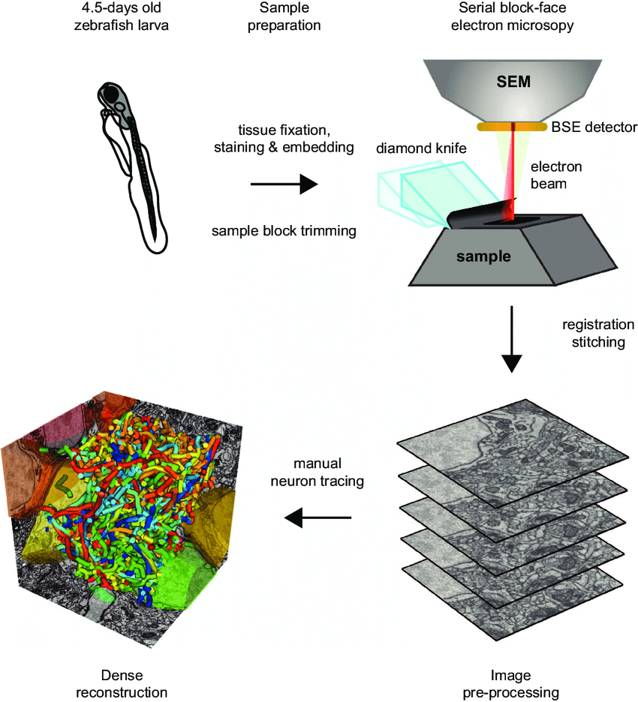SBEM

[1]SBEM is serial block face electron microscopy.  
It is done in the following steps:

1. Sample Collection:   
   The tissue is harvested from the specimen.
2. Sample Preparation:

Tissue Fixation, Staining, and Embedding: The tissue is fixated to preserve its structure, stained to enhance contrast for imaging, and embedded in a resin to create a solid block for sectioning.

1. Sample Block Trimming:

The embedded sample is trimmed into a smaller, manageable block suitable for microscopy.

1. Serial Block-Face Electron Microscopy (SBEM):

The trimmed sample block is placed in an SBEM setup. An electron beam scans the sample, and a diamond knife cuts ultrathin slices from the block's surface after each scan.

A Backscattered Electron (BSE) detector captures images of the freshly exposed surface, generating a series of 2D images as the block is progressively sliced.

1. Image Pre-processing:

Registration and Stitching: The series of 2D images are aligned (registered) and stitched together to ensure continuity and correct for any misalignments during imaging.

Alpha Cells

Alpha retinal ganglion cells are retinal neurons distinguished by their large cell bodies, stout axons and large mono-stratified dendritic arbours. Alpha cells have large cell bodies, stout dendrites and axons, and large mono-stratified dendritic fields. They exhibit a short response latency and fast-conducting axons, making them among the first to signal new visual stimuli to the brain. Alpha cells have a large receptive field center with a weak antagonistic surround and lack direction selectivity. [4]

Alpha retinal Ganglion cells are necessary for visual information transmission from the retina to the brain to areas like the superior colliculus (SC) and dorsal lateral geniculate nucleus (dLGN), rapid transmission of visual information and contributing to motion detection and other time-sensitive visual tasks.

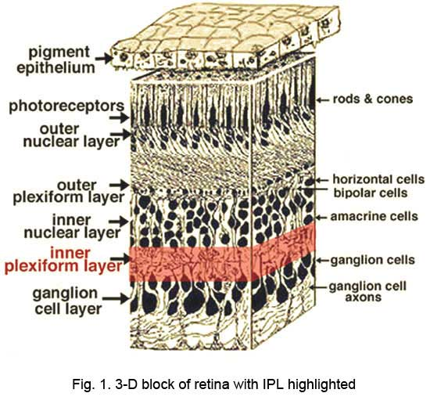Alpha cells are part of the multiple parallel channels that process different aspects of visual information, enhancing the retina's ability to encode a wide range of visual stimuli.

Figure: Cross section of retina[3]

Synapses

The places where neurons connect and communicate with each other are called synapses. Each neuron has anywhere between a few to hundreds of thousands of synaptic connections, which can be with itself, neighboring neurons, or neurons in other brain regions. A synapse is made up of a presynaptic and postsynaptic terminal. The presynaptic terminal is at the end of an axon, where the electrical signal (the action potential) is converted into a chemical signal (neurotransmitter release). The postsynaptic terminal membrane is less than 50 nanometers away and contains specialized receptors. The neurotransmitter rapidly (in microseconds) diffuses across the synaptic cleft and binds to specific receptors. The type of neurotransmitter released from the presynaptic terminal and the specific receptors on the corresponding postsynaptic terminal are critical in determining the quality and intensity of information transmitted by neurons.[5]

In this report, 3 types of synapses have been identified:[5,6,7,8,9,10]

1. 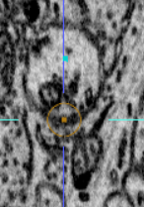Inhibitory Wrap-around Synapse: the presynaptic end appears to wrap around the postsynaptic region as shown in the figure.

Presynaptic surface

Presynaptic surface

1. 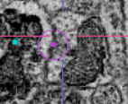Inhibitory Flat Synapse: the presynaptic-postsynaptic junction resembles a flat surface.

Postsynaptic surface

Presynaptic surface

1. Excitatory Synapse: 1 presynaptic surface transmits vesicles to 2 postsynaptic surfaces.

Presynaptic surface

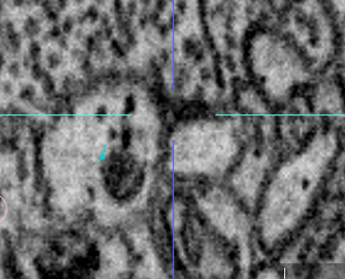

Postsynaptic surface

Postsynaptic surface

Methods:

The dataset[2] contained a vast number of images which had been previously taken in SBEM methods.

The alpha cell was manually traced from pre-processed image stack by identifying and mapping the structures in 3D space using Webknossos.

The dendrites were traced using cyan colour. Synapses were traced as separate unimodal trees and marked as ie (inhibitory synapse, wrap-around), if (inhibitory synapse, flat) and exc (excitatory). After marking, the entire skeleton containing all the trees and the synapses was downloaded as an NML file. The data was then processed to extract the node ids, x , y, z coordinates and comments against each node plotted on the neuron including the dendrites and synapses.

Using Excel and Python, the data was processed and then node points were plotted them in XY, YZ, XZ faces, along with their nodes and synapses.

Results:

Neurons and synapses have been identified as shown along the different axes.

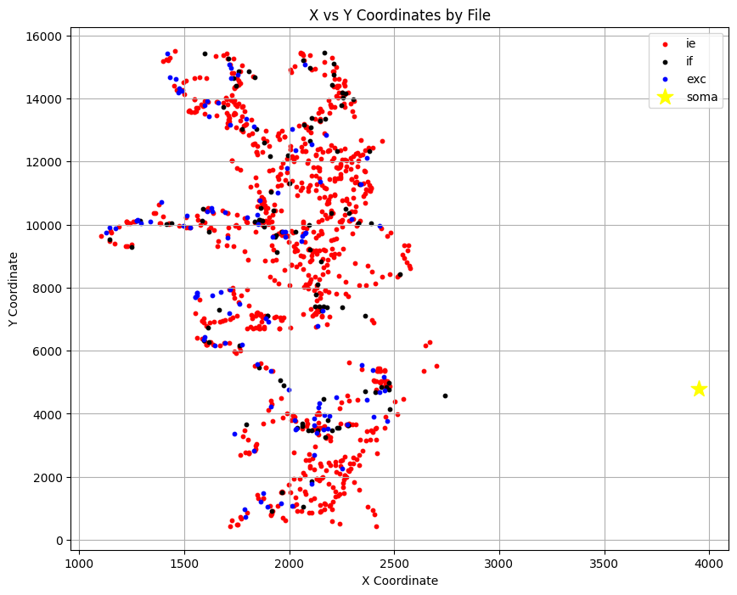Neurons:

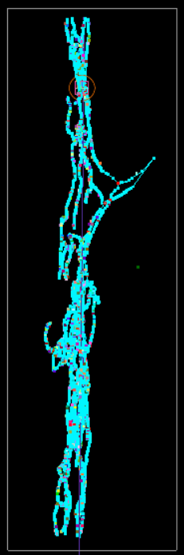

XY Plane

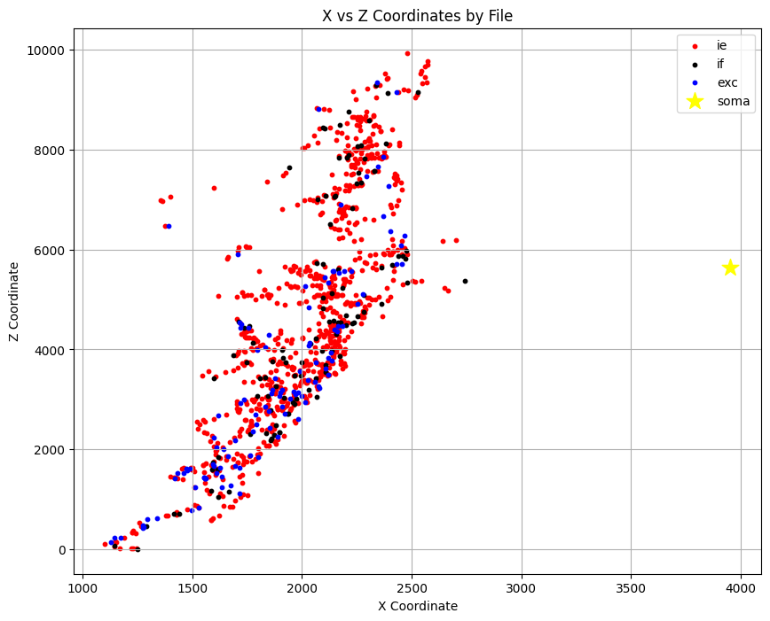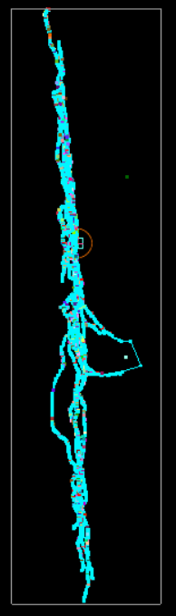

XZ Plane

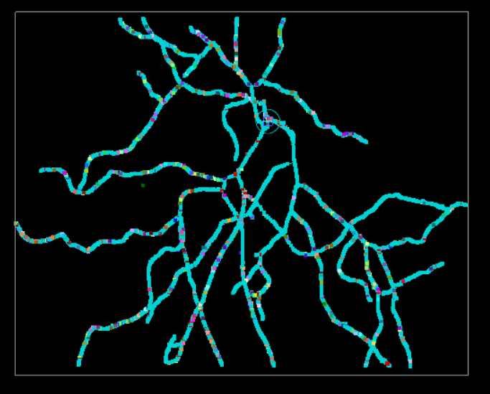

YZ Plane

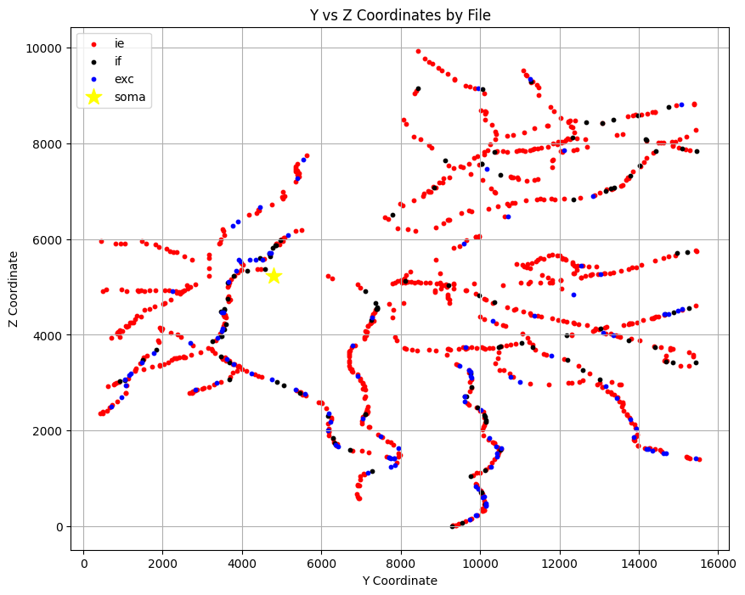

Discussions

The inhibitory wraparound neurons are present uniformly in the dendritic tree. The excitatory and inhibitory-flat synapses are more towards periphery: between 0.55 to 0.85 distances plotted along the map.

Also, only 3 dendrites are densely clustered by the excitatory synapses, and a probable consequence of this is direction selective excitation or function of the neuron.

Total tree length: 2.6mm

Total synapses:

* 858 inhibitory wrap-around
* 97 excitatory
* 112 inhibitory flat

So average synaptic density:

* Inhibitory wraparound: 0.33 synapses per micron
* Inhibitory flat: 0.04 synapses per micron
* Excitatory: 0.037 synapses per micron.

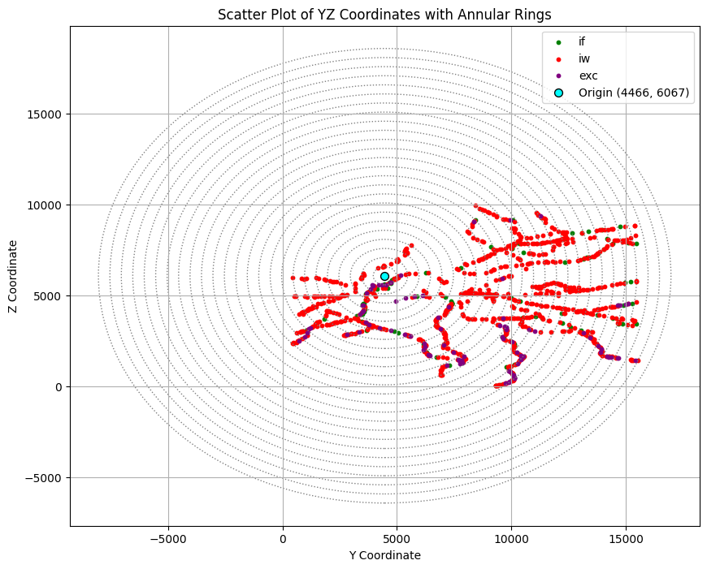

|  |  |  |  |  |  |  |
| --- | --- | --- | --- | --- | --- | --- |
| **Inner Radius** | **Outer Radius** | **annular space** | **Circle radius** | **inhibitory flat** | **inhibitory wraparound** | **excitatory** |
| 0 | 500 | 785398.1634 | 500 | 5 | 5 | 3 |
| 500 | 1000 | 2356194.49 | 1000 | 4 | 22 | 6 |
| 1000 | 1500 | 3926990.817 | 1500 | 2 | 21 | 2 |
| 1500 | 2000 | 5497787.144 | 2000 | 6 | 24 | 5 |
| 2000 | 2500 | 7068583.471 | 2500 | 4 | 24 | 3 |
| 2500 | 3000 | 8639379.797 | 3000 | 4 | 39 | 3 |
| 3000 | 3500 | 10210176.12 | 3500 | 11 | 64 | 6 |
| 3500 | 4000 | 11780972.45 | 4000 | 3 | 62 | 2 |
| 4000 | 4500 | 13351768.78 | 4500 | 2 | 52 | 5 |
| 4500 | 5000 | 14922565.1 | 5000 | 8 | 60 | 6 |
| 5000 | 5500 | 16493361.43 | 5500 | 2 | 34 | 3 |
| 5500 | 6000 | 18064157.76 | 6000 | 4 | 52 | 12 |
| 6000 | 6500 | 19634954.08 | 6500 | 10 | 51 | 6 |
| 6500 | 7000 | 21205750.41 | 7000 | 6 | 41 | 2 |
| 7000 | 7500 | 22776546.74 | 7500 | 3 | 50 | 4 |
| 7500 | 8000 | 24347343.07 | 8000 | 9 | 69 | 14 |
| 8000 | 8500 | 25918139.39 | 8500 | 2 | 40 | 0 |
| 8500 | 9000 | 27488935.72 | 9000 | 7 | 20 | 0 |
| 9000 | 9500 | 29059732.05 | 9500 | 3 | 29 | 1 |
| 9500 | 10000 | 30630528.37 | 10000 | 5 | 29 | 1 |
| 10000 | 10500 | 32201324.7 | 10500 | 3 | 30 | 5 |
| 10500 | 11000 | 33772121.03 | 11000 | 8 | 25 | 5 |
| 11000 | 11500 | 35342917.35 | 11500 | 2 | 10 | 2 |
| 11500 | 12000 | 36913713.68 | 12000 | 0 | 5 | 1 |
| 12000 | 12500 | 38484510.01 | 12500 | 0 | 0 | 0 |

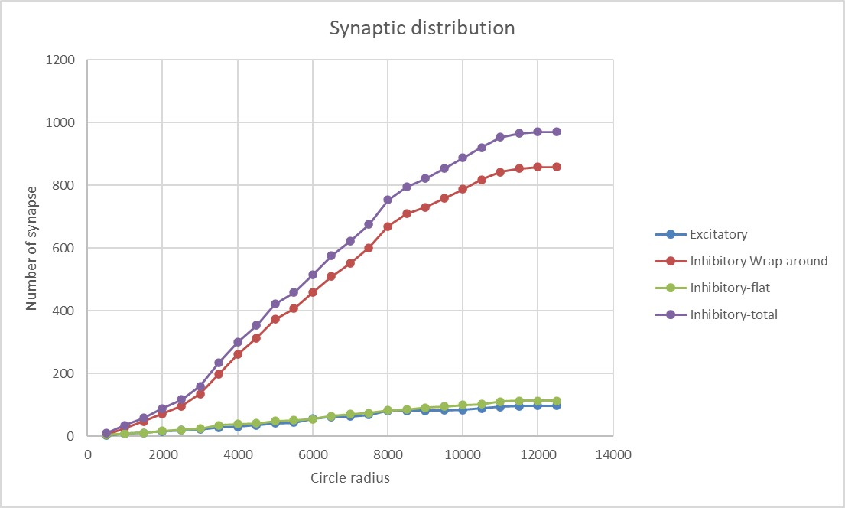

Future plans:

To plot the same for 2 more ON Alpha cells, 1 more OFF Alpha cell and 1 amacrine cell

References

1. A SBEM image file was taken from Webknossos ID:

Mouse retina 110629_k0725

1. Krieger, Brenna, Mu Qiao, David L. Rousso, Joshua R. Sanes, and Markus Meister. 2017. “Four alpha ganglion cell types in mouse retina: Function, structure, and molecular signatures.” PLoS ONE 12 (7): e0180091. doi:10.1371/journal.pone.0180091. http://dx.doi.org/10.1371/journal.pone.0180091.
2. <https://webvision.med.utah.edu/book/part-i-foundations/simple-anatomy-of-the-retina/>
3. Caire MJ, Reddy V, Varacallo MA. Physiology, Synapse. [Updated 2023 Mar 27]. In: StatPearls [Internet]. Treasure Island (FL): StatPearls Publishing; 2025 Jan-. Available from: <https://www.ncbi.nlm.nih.gov/books/NBK526047/>

Id: 6792254c010000d0025a7b43

1. Wanner, Adrian & Genoud, Christel & Friedrich, Rainer. (2016). 3-dimensional electron microscopic imaging of the zebrafish olfactory bulb and dense reconstruction of neurons. Scientific Data. 3. 160100. 10.1038/sdata.2016.100.
2. Alex Hoggarth, Amanda J. McLaughlin, Kara Ronellenfitch, Stuart Trenholm, Rishi Vasandani, Santhosh Sethuramanujam, David Schwab, Kevin L. Briggman, Gautam B. Awatramani,Specific Wiring of Distinct Amacrine Cells in the Directionally Selective Retinal Circuit Permits Independent Coding of Direction and Size,Neuron,Volume 86, Issue 1,2015,Pages 276-291,ISSN 0896-6273, <https://doi.org/10.1016/j.neuron.2015.02.035>.
3. Sethuramanujam S, Yao X, deRosenroll G, Briggman KL, Field GD, Awatramani GB. "Silent" NMDA Synapses Enhance Motion Sensitivity in a Mature Retinal Circuit. Neuron. 2017 Dec 6;96(5):1099-1111.e3. doi: 10.1016/j.neuron.2017.09.058. Epub 2017 Nov 5. PMID: 29107522; PMCID: PMC5975974.
4. Sethuramanujam S, Matsumoto A, deRosenroll G, Murphy-Baum B, Grosman C, McIntosh JM, Jing M, Li Y, Berson D, Yonehara K, Awatramani GB. Rapid multi-directed cholinergic transmission in the central nervous system. Nat Commun. 2021 Mar 2;12(1):1374. doi: 10.1038/s41467-021-21680-9. Erratum in: Nat Commun. 2021 Apr 21;12(1):2441. doi: 10.1038/s41467-021-22763-3. PMID: 33654091; PMCID: PMC7925691.
5. Sethuramanujam S, Matsumoto A, deRosenroll G, Murphy-Baum B, Grosman C, McIntosh JM, Jing M, Li Y, Berson D, Yonehara K, Awatramani GB. Rapid multi-directed cholinergic transmission in the central nervous system. Nat Commun. 2021 Mar 2;12(1):1374. doi: 10.1038/s41467-021-21680-9. Erratum in: Nat Commun. 2021 Apr 21;12(1):2441. doi: 10.1038/s41467-021-22763-3. PMID: 33654091; PMCID: PMC7925691.
6. Philip SA*, Singh NP*, Viswanathan S, Parida P, **Sethuramanujam S**. 2025. Asymmetries in the Architecture of ON and OFF Arbors in ON–OFF Direction-Selective Ganglion Cells. Journal of Comparative Neurology **533**:e70023.